Growth Table

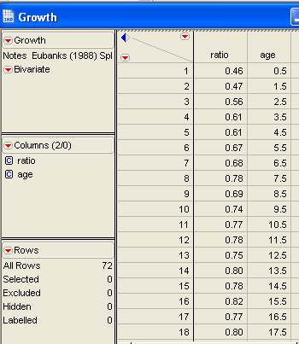

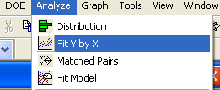

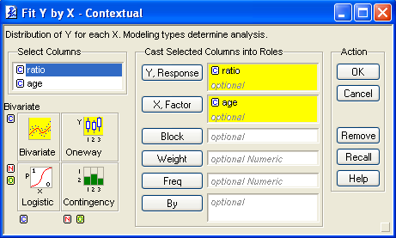

Age (x) generates the ratio (y)
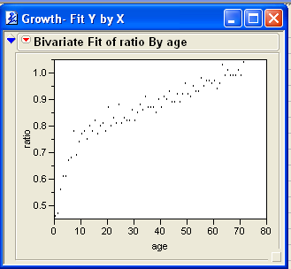

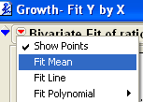

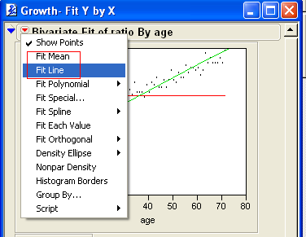

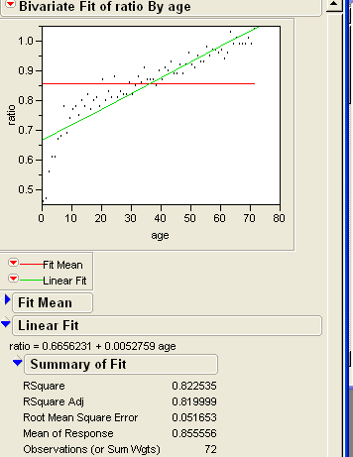
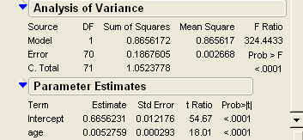

R² is 82.25% high correlation

Mean is 0.8555 (red line)

Good approximation < 0.0001 so 99.9% confident for intercept and X (age)

Y = 0.0052759 X + 0.6656231

With the standard error we can create a confident interval +/-3 standard error?

EXCLUDE POINTS

At the beginning, from 0-7 the line is different, we will exclude those points

- Select from top menu Tools - Lasso
- Drag the lasso around the points to be excluded

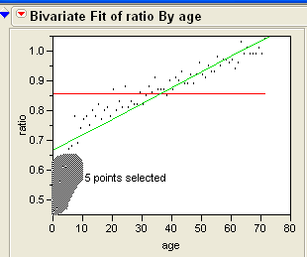

- Select from top menu Rows – Exclude/Unexclude
- Right click the selected points and select Rows – Marker
- Assign the X marker

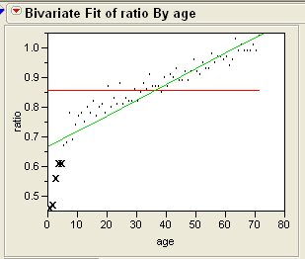

- Then click the red icon in the title bar and choose the Fit Line again

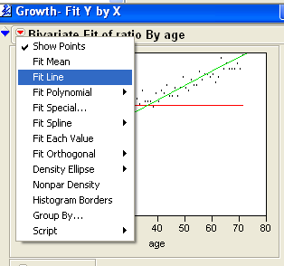

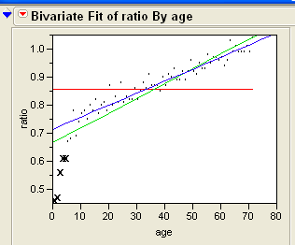

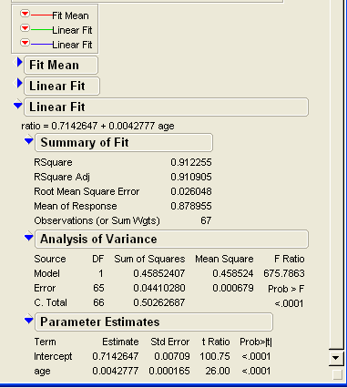

New equation Y = 0.004277 X + 0.7142

EXAMINING A POLYNOMIAL FIT

Include again the points by clicking the graph to select again the points

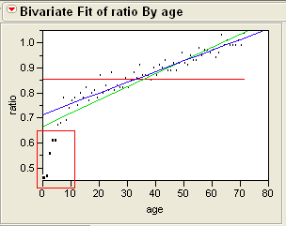
The markers are removed

Click Rows – Exclude/unexclude

Click red arrow and select Fit Polynomial

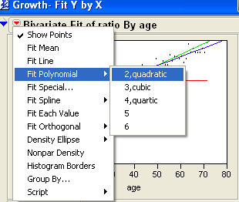

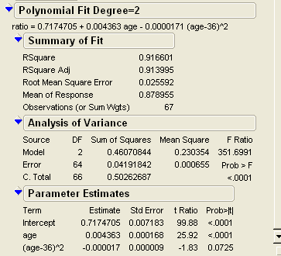

Y = 0.7174 + 0.0043 X – 0.000017 (X-36) ²

However when we select cubic the RSquare is higher (0.923 > 0.916) , which means a better fit

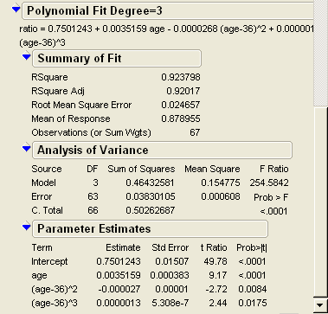

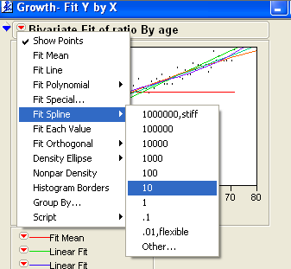

Click the red triangle and select Fit Spine 3 times, with lambda values of 10, 1,000 100,000

Fit Spline for 10

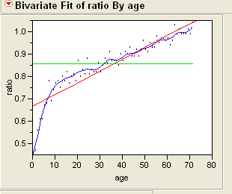

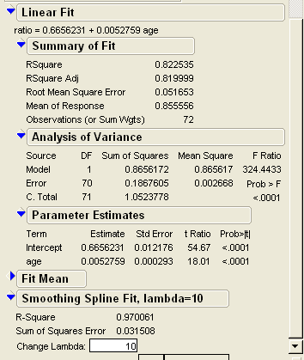

Get the highest R-Square 0.97

FITTING BY GROUPS

Obviosly there are 2 lines, before and after 12 years old

Let include a new columns

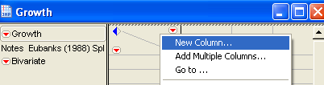

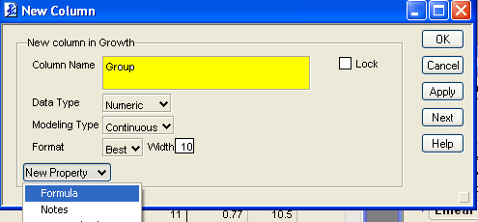

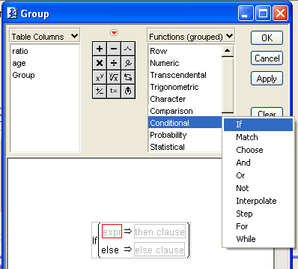

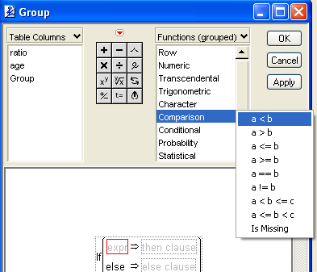

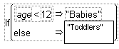

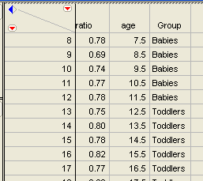

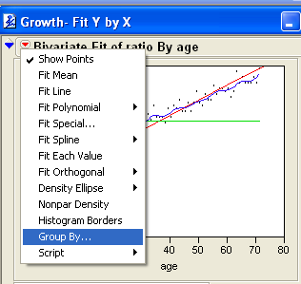

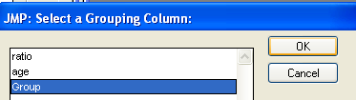

Then choose fit line

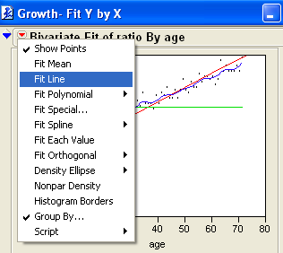

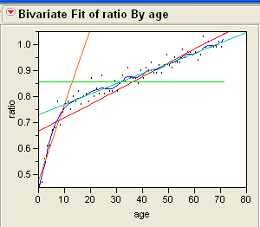

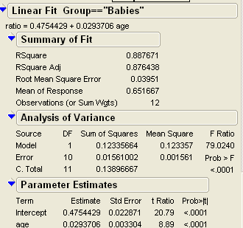

Y = 0.4754 + 0.029 X if X <12

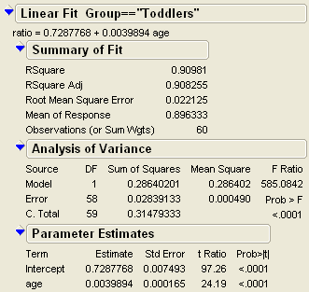

Y = 0.7287 + 0.0039 X if X >11

Comparing with one line the

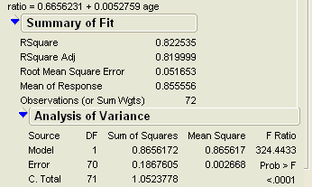

R² of line for all values 0.82
R² of line for babies 0.88
R² of line for toddlers 0.90

Better use the 2 lines

- Y = 0.4754 + 0.029 X if X <12

- Y = 0.7287 + 0.0039 X if X >11

